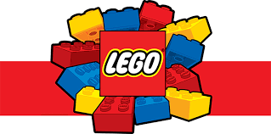
June 4th
Hello Boys and Girls,
The month of June is here and if we were in school, we would be playing lots of Lego every day. I know you all love playing with Lego.
I am setting you a challenge in Lego. I know that lots of you have boxes of Lego at home. I know some of you are Lego fans.
I want to see how many things you can create in Lego.
There are 30 days in month of June and I’m giving you 30 different things to make. Everyday there is different challenge.
I would love to see what you are making and creating in Lego.
You can send on photos of what you make out of Lego and tell me which day of the Lego plan you followed to niamhw@sprox.ie and we will share them on the school website.
Have lots of fun.
Love Mr Cuddles XXXXX

